How to Import File into GitHub Using Shell

1. Open GitHub Desktop

https://i.gyazo.com/3da93a2a0847ab088c9b64399c281e04.png

1. Log in using your GitHub account

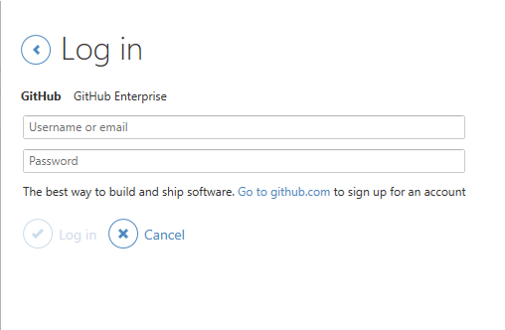

1. Clone repository being used to store files on GitHub

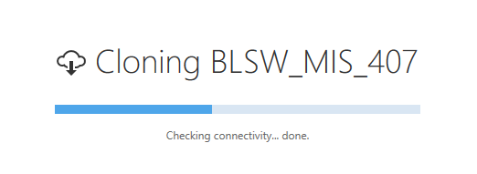

1. Once cloned, navigate to file directory using explorer on machine -> C:\Users\Michael\Documents\GitHub\BLSW_MIS_407

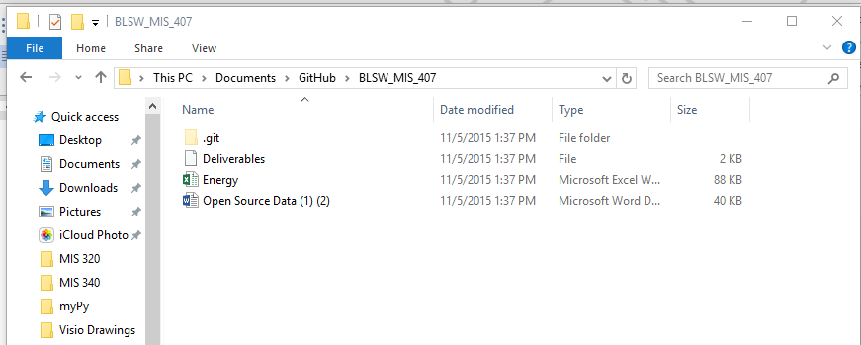

1. Place file inside of directory

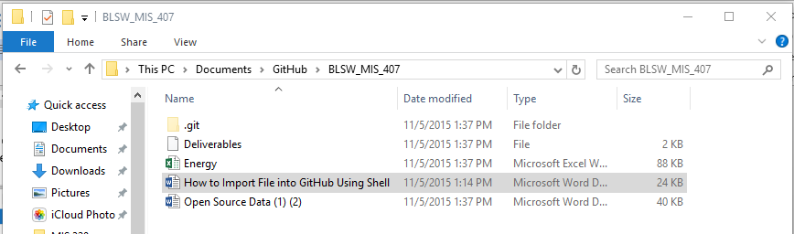

1. Once file is in directory, go back to GitHub Desktop and go to the settings wheel, open in Git Shell, this will open the repository in the Shell.

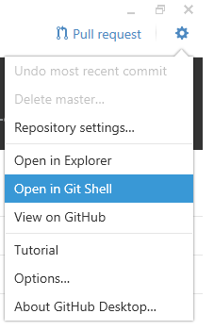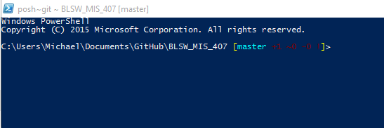

1. Once the Shell is open, initialize the repository by using the command “git init”

https://i.gyazo.com/d3a4737f5d5ab9debb95ba52b30aec5a.png

1. Once initialized, use the command “git add “FileName.extension”” to ADD a file

https://i.gyazo.com/d331b2293b2efcf550127b4f78f10022.png

1. Next, use the command “git commit” and a notepad.txt file should appear. Put message on first line without the ‘#’ character

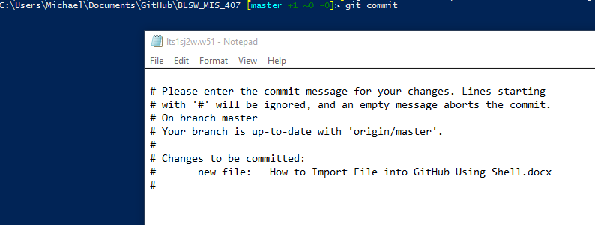

1. Save and close the file.
2. Once step 10 is done, go to GitHub Desktop and click Sync.
3. Go to GitHub web version and see if your file is there! ☺